
Functional Materials Manufacturing, Inc.

Ceramic Cutting Tools
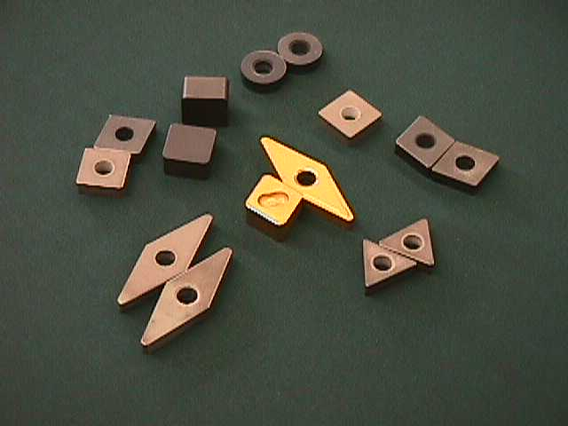

Increasing Productivity
Through Innovation

555 Gore Road
Kingston, Onatrio, Canada K7L 5H6
Tel: (613)484-0603
Fax: (613)533-6610


INTRODUCTION

FMM offers a broad range of high performance ceramic cutting tools. Ceramics possess high melting points, high hardness and excellent wear resistance and ability to retain mechanical properties at high temperatures thus making them highly suitable for high speed machining. Interest in ceramics as a high-speed cutting tool for machining of most common metals and alloys has increased over the decade, due to potentials to increase the productivity of metal cutting operations by an order of magnitude. Our silicon nitride and SiAlON based tools have the best combination of hardness and toughness allowing a major increase in cutting speed. For example, it has been possible to increase the cutting speeds form ~200 sm/min for tool steel to over 2600 sm/min for silicon nitride cutting tools.
Most significant application of ceramic cutting tool grades FM02, FM55C and FM73C is in machining of hard steel and iron (up to 64 HRC). Also, roughing and finishing can be performed in one step operation.
Due to continuous research and advancement in cutting tool materials, new grades of ceramic cutting tools based on silicon nitride and titanium carbide for even higher cutting speeds are being introduced.
This catalogue offers FMM’s state of the art ceramic cutting tools renowned for their high quality and versatility.

TABLE OF CONTENTS | PAGE
1. Ceramic Cutting Tool Grades................................................................... | 3
2. Insert Identification.................................................................................... | 4
3. Ceramic Inserts for Turning and Boring................................................. | 5
4. Technical Data............................................................................................ | 8
4.1. Recommendations for Turning | 19
4.2. Definitions of Terms and Formulas | 20
4.3. Machining Recommendations for Turning  4.4. Suggestions for the Ceramic User  4.5. Feedrate Selection for Turning with Ceramic Cutting Tools  4.6. Basic Formulas  4.7. Edge Preparation | 21  27  28  29  30

Grade | Composition | Application
FMA | Aluminum Oxide, pure | Fine finishing of soft cast irons and steels with hardness of up to 35 HRC (330 BHN)
FMAZ1 | Aluminum Oxide-Zirconium Oxide (10 vol %) | Finishing of gray cast iron, carbon steel, alloy steel with hardness of up to 38 HRC (350BHN)
FMAZ2 | Aluminum Oxide-Zirconium Oxide (20 vol %) | Roughing of gray cast iron, ductile cast iron, carbon steel, alloy steel and tool steel with hardness of up to 38 HRC (350 BHN)
FMAZ3 | Aluminum Oxide-Titanium Carbide (30 wt %) | Roughing and finishing hard steel with hardness of up to 64 HRC (740 BHN)
FM02 | Silicon Nitride with Metal Oxides | Roughing, turning and milling of gray cast iron
FM55C | Silicon Nitride Based Ceramics | Roughing, turning and milling of gray cast iron
FM64C | Silicon Nitride Based Ceramics | Roughing, turning and milling of gray cast iron
FM73C | Silicon Nitride Based Ceramics | Roughing, turning and milling of gray cast iron
FMYC | SiAlON Based Ceramics | Roughening and finishing of cast iron, carbon steel, alloy steel and tool steel
FMTCN | Titanium Carbide-Based Cermet





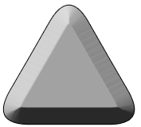
C-Rhombic (Diamond 80)

D- Rhombic (Diamond 55)

R-Round

S-Square

T-Triangle

1 INSERT SHAPE
- C

- D
- R
- S
- T

N - Without Hole
4 INSERT TYPE
N - 0 
P - 11 
2 RADIUS
G | +/- I.C.  .001 In  .025mm | +/- B  .001 In  .025 mm | +/- T  .005 In  .13mm
3 TOLERANCE

3
G
4
N
5
12
6
03
1
S
2
P
7
08
5 INSERT SIZE
I.C. Inch | C | D | R | S | T
1/4 | 06 | 07 | - | 06 | 11
3/8 | 09 | 12 | 09 | 09 | 16
1/2 | 12 | 15 | 12 | 12 | 22
5/8 | 16 | 19 | 15 | 15 | 27
3/4 | 19 | 23 | 19 | 19 | 33
1 | 25 | 31 | 25 | 25 | 44

6 THICKNESS
Inch | Symbol
1/8 | 3
3/16 | 4
1/4 | 6
5/16 | 7
3/8 | 9
7 RADIUS
Inch | Symbol
1/64 | 4
1/32 | 8
3/64 | 12
1/16 | 16
1/8 | 32

CNG 80° diamond negative rake Insert
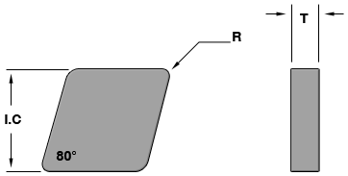

Insert Number | ISO Designation | Specifications |  |  |  | All Grades
Insert Number | ISO Designation | E.P | I.C. | T | R | FMA | FMAZ1 | FMAZ2 | FMAZ3 | FM FM FM FM FM  02 C55 64C 73C 1515
CNG-432  CNG-433 | CNGN 120408  CNGN 120412 | T-01  T-02 | 1/2  1/2 | 3/16  3/16 | 1/32  3/64 | ♦  ♦ |  |  | ♦  ♦ | ○  ♦ ○
CNG-452  CNG-453  CNG-453  CNG-454  CNG-454 | CNGN 120708  CNGN 120712  CNGN 120712  CNGN 120716  CNGN 120716 | T-02  T-02  T-03  T-02  T-03 | 1/2  1/2  1/2  1/2  1/2 | 5/16  5/16  5/16  5/16  5/16 | 1/32  3/64  3/65  1/16  1/16 | ○  ○  ○  ○  ○ | ♦  ♦ | ♦  ♦ | ♦  ♦ | ♦
CNG- 542  CNG- 543  CNG -544 | CNGN 160608  CNGN 160612  CNGN 160716 | T-02  T-02  T-02 | 5/8  5/8  5/8 | 1/4  1/4  1/4 | 1/32  3/64  1/16 |  |  |  | ♦  ♦
CNG- 553  CNG- 553  CNG- 554 | CNGN 160712  CNGN 160712  CNGN 160716 | T-02  T-03  T-03 | 5/8  5/8  5/8 | 5/16  5/16  5/16 | 3/64  3/64  1/16 |  |  | ♦  ♦  ♦ | ♦  ♦ | ♦
CNG- 642  CNG- 643  CNG- 644  CNG- 648 | CNGN 190608  CNGN 190612  CNGN 190616  CNGN 190632 | T-02  T-02  T-02  T-02 | 3/4  3/4  3/4  3/4 | 1/4  1/4  1/4  1/4 | 1/32  3/64  1/16  1/8 | ♦ |  |  | ♦  ♦  ♦  ♦
CNG- 653  CNG- 654  CNG- 658 | CNGN 190712  CNGN 190716  CNGN 190732 | T-02  T-02  T-02 | 3/4  3/4  3/4 | 5/16  5/16  5/16 | 3/64  3/64  1/16 |  |  | ♦ | ♦  ♦  ♦

CPG 80° diamond positive rake Insert 11° clearance

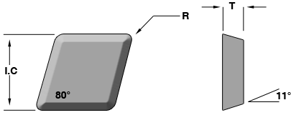

Insert Number | ISO Designation | Specifications |  |  |  | Grades
Insert Number | ISO Designation | E.P | I.C. | T | R |  | FMTCN
CPG-422  CPG-423 | CPGN 120308  CPGN 120312 | T-02  T-02 | 1/2  1/2 | 1/8  1/8 | 1/32  1/32 |  | ○  ○
CPG-432 | CPGN 120408 | T-02 | 1/2 | 3/16 | 1/32 |  | ○

CNGA 80° diamond negative rake Insert

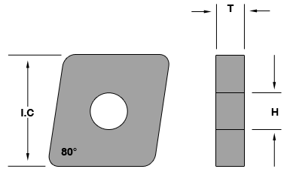

Insert Number | ISO Designation | Specifications |  |  |  |  | All Grades
Insert Number | ISO Designation | E.P | I.C. | T | R | H | FM  02 | FM73C | FM64C | FMY515
CNGA-431  CNGA-432 | CNGA 120404  CNGA 120408 | T-02  T-02 | 3/8  3/8 | 3/16  3/16 | 1/64  1/32 | .150  .150 | ♦  ♦ | ♦  ♦ | ♦  ♦ | ♦  ♦
CNGA- 433  CNGA- 434 | CNGA 120412  CNGA 120416 | T-02  T-02 | 1/8 | 3/16 | 1/32 | .203 | ♦ | ♦ | ♦ | ♦

DNG 55° diamond negative rake Insert
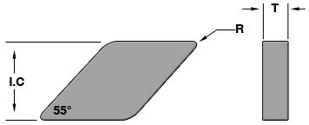

Insert Number | ISO Designation | Specifications |  |  |  | All Grades
Insert Number | ISO Designation | E.P | I.C. | T | R | FM02 | FM73C | FMY515
DNG-432  DNG-433 | DNGN 150408  DNGN 150412 | T-02  T-02 | 1/2  1/2 | 3/16  3/16 | 1/32  3/64 | ♦  ♦ | ♦  ♦ | ○  ○
DNG-442  DNG-443  DNG-444 | DNGN 150608  DNGN 150612  DNGN 150616 | T-02  T-02  T-02 | 1/2  1/2  1/2 | 1/4  1/4  1/4 | 1/32  3/64  1/16 |  | ♦  ♦ | ○  ○  ♦
DNG- 532  DNG- 533 | DNGN 190408  DNGN 190412 | T-02  T-02 | 5/8  5/8 | 3/16  3/16 | 1/32  3/64 |  | ○  ○ | ○  ○
DNG -542  DNG- 543  DNG- 544 | DNGN 190608  DNGN 190612  DNGN 190616 | T-02  T-02  T-02 | 5/8  5/8  5/8 | 1/4  1/4  1/4 | 1/32  3/64  1/16 | ♦ | ♦  ♦  ♦

DNGA 55° diamond negative rake Insert

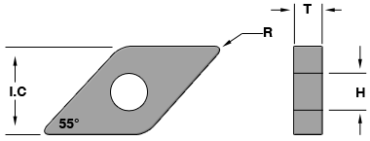

Insert Number | ISO Designation | Specifications |  |  |  |  | All Grades
Insert Number | ISO Designation | E.P | I.C. | T | R | H | FM  02 | FM  73C | FM  64C | FMY515
DNGA-331  DNGA-332 | VNGA 151404  VNGA 151408 | T-02  T-02 | 3/8  3/8 | 3/16  3/16 | 1/64  1/32 | .150  .150 | ♦  ♦ | ♦  ♦ | ♦  ♦ | ♦  ♦
DNGA- 432 | VNGA 151408 | T-02 | 1/8 | 3/16 | 1/32 | .203 | ♦ |  | ♦

RNG ^{Negative rake Insert}
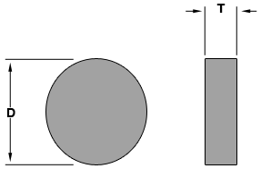

Insert Number | ISO Designation | Specifications |  |  | All Grades
Insert Number | ISO Designation | E.P | D | T | FM02 | FM73C | FMY515
RNG-32 | RNGN 090300 | T-02 | 3/8 | 1/8 | ♦ | ♦ | ♦
RNG-42  RNG-43  RNG-45 | RNGN 120300  RNGN 120400  RNGN 120700 | T-02  T-02  T-02 | 1/2  1/2  1/2 | 1/32  3/64  1/16 |  | ♦  ♦  ♦ | ○  ♦  ♦
RNG- 55  RNG- 65 | RNGN 150700  RNGN 190700 | T-02  T-02 | 5/8  3/4 | 1/32  3/64 |  | ♦  ♦ | ○  ○
RNG -85  RNG- 86 | RNGN 250700  RNGN 250900 | T-02  T-02 | 1  1 | 5/16  5/8 |  | ♦  ♦ | ♦  ○

RPG ^{positive rake Insert}
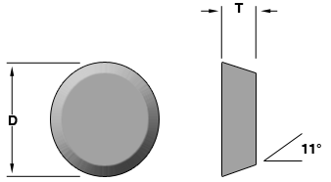

Insert Number | ISO Designation | Specifications |  |  | Grades
Insert Number | ISO Designation | E.P | D | T |  | FMTCN
RPG-32  RPG-43 | RPGN 090300  RPGN 120400 | T-02  T-02 | 3/8  1/2 | 1/8  3/16 |  | ○  ○

RCGX positive rake Insert V bottom insert

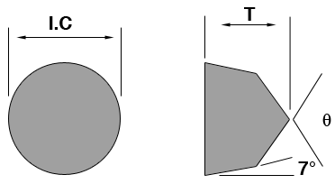

Insert Number | ISO Designation | Specifications |  |  | Grades
Insert Number | ISO Designation | E.P | I.C | T | FMAZ1 | FM  AZ2 | FM  AZ3
RCGX-32  RCGX-43 |  | T-02  T-02 | 3/8  1/2 | 1/8  3/16 |  | ♦  ♦ | ♦  ♦

SNG ^{Negative rake Insert}
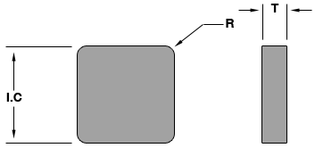

Insert Number | ISO Designation | Specifications |  |  |  | All Grades
Insert Number | ISO Designation | E.P | I.C. | T | R | FM02 | FM64C | FM73C | FM55C | FMY515
SNG-322 | SNGN 090308 | T-01 | 3/8 | 1/8 | 1/32 | ♦ |  |  | ♦ | ♦
SNG-432  SNG-433  SNG-434  SNG-436  SNG-438 | SNGN 120408  SNGN 120412  SNGN 120416  SNGN-120424  SNGN-120432 | T-02  T-02  T-02  T-02  T-02 | 1/2  1/2  1/2  1/2  1/2 | 3/16  3/16  3/16  3/16  3/16 | 1/32  3/64  1/16  3/32  1/8 | ♦  ♦  ♦  ♦  ♦ | ○  ○  ○  ○  ○ | ○  ○  ○  ○  ○ | ♦  ♦  ♦  ♦  ♦ | ♦  ♦  ♦  ♦  ♦
SNG-452  SNG-453  SNG-454 | SNGN 120708  SNGN 120712  SNGN-120716 | T-02  T-02 | 1/2  1/2  1/2 | 5/16  5/16  5/16 | 1/32  3/64  1/16 | ♦  ♦  ♦ | ♦  ♦  ♦ | ♦  ♦  ♦ | ♦  ♦  ♦ | ♦  ♦  ♦
SNG-553  SNG-554  SNG-554  SNG-554 | SNGN 150712  SNGN 150716  SNGN 150716  SNGN 150724 | T-02  T-02  T-02  T-02 | 5/8  5/8  5/8  5/8 | 5/16  5/16  5/16  5/16 | 3/64  1/16  1/16  3/32 | ♦  ♦ | ○  ○  ○ | ○  ○  ♦ | ♦  ♦  ♦ | ○  ○  ○  ○  ○

SNGA ^{Negative rake Insert}

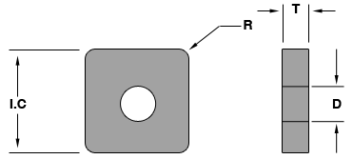

Insert Number | ISO Designation | Specifications |  |  |  |  | All Grades
Insert Number | ISO Designation | E.P | I.C. | T | R | D | FM02 | FM64C | FM73C | FMY515
SNGA-322 | SNGA 090308 | T-02 | 3/8 | 1/8 | 1/32 | .150 |  |  | ♦
SNGA-432  SNGA-433  SNGA-434 | SNGA 120408  SNGA 120412  SNGA 120416 | T-02  T-02  T-02 | 1/2  1/2  1/2 | 3/16  3/16  3/16 | 1/32  3/64  1/16 | .203  .203  .203 | ♦  ♦  ♦ | ♦  ♦  ♦ | ♦  ♦  ♦ | ♦  ♦  ♦

SPG ^{Positive rake Insert}
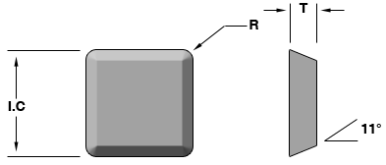

Insert Number | ISO Designation | Specifications |  |  |  | Grades
Insert Number | ISO Designation | E.P | I.C. | T | R | FM | FM | FM | FMTCN | FM
SPG-321  SPG-322  SPG-323 | SPGN 090304  SPGN 090308  SPGN 090312 | T-01  T-01  T-01 | 3/8  3/8  3/8 | 1/8  1/8  1/8 | 1/64  1/32  1/64 |  |  |  | ○  ○  ○
SPR-421  SPR-422  SPR-423 | SPGN 120304  SPGN 120308  SPGN 312 | T-01  T-01  T-01 | 1/2  1/2  1/2 | 1/8  1/8  1/8 | 1/64  1/32  3/64 |  |  |  | ○  ○  ○
SPG-433  SPG-434 | SPGN 120412  SPGN 120416 | T-02  T-02 | 1/2  1/2 | 3/16  3/16 | 3/64  1/16 |  |  |  | ○  ○

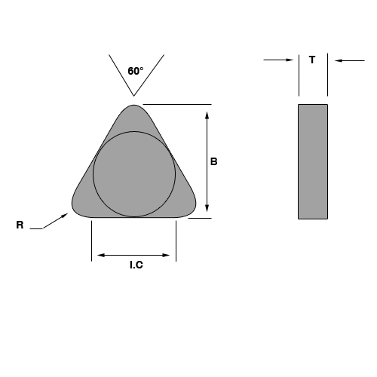
TNG ^{Negative rake Insert}

Insert Number | ISO Designation | Specifications |  |  |  |  | All Grades
Insert Number | ISO Designation | E.P | I.C. | T | R | B | FM  02 | FM64C | FM73C | FMY515
TNG-222 | TNGN 110308 | T-02 | 1/4 | 1/8 | 1/32 | .3437 |  |  | ○
TNG-322 | TNGN 160308 | T-02 | 3/8 | 1/8 | 1/32 | .5312 | ♦ |  | ♦ | ♦
TNG-332  TNG-333  TNG-334 | TNGN 160408  TNGN 160412  TNGN 160416 | T-02  T-02  T-02 | 3/8  3/8  3/8 | 3/16  3/16  3/16 | 1/32  3/64  1/16 | .5312  .5156  .5000 | ♦  ♦  ♦ | ♦  ♦  ♦ | ♦  ♦  ♦ | ♦  ♦  ♦
TNG- 352  TNG- 353 | TNGN 160708  TNGN 160712 | T-02  T-02 | 3/8  3/8 | 5/16  5/16 | 1/32  3/64 | .5312  .5156 | ♦ |  | ♦  ♦
TNG-432  TNG-433  TNG-434 | TNGN 220408  TNGN 220412  TNGN 22-416 | T-02  T-02  T-02 | 1/2  1/2  1/2 | 3/16  3/16  3/16 | 1/32  3/64  1/16 | .7188  .7031  .6875 | ♦  ♦  ♦ |  | ♦  ♦  ♦ | ♦  ♦  ♦
TNG- 453  TNG- 454 | TNGN 190608  TNGN 190612 | T-02  T-02 | 1/2  1/2 | 5/16  5/16 | 3/64  1/16 | .7031  .6875 | ♦  ♦ |  | ♦  ♦

TNGA ^{Negative rake Insert}
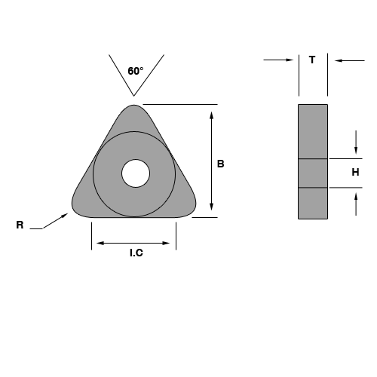

Insert Number | ISO Designation | Specifications |  |  |  |  |  | All Grades
Insert Number | ISO Designation | E.P | I.C. | T | R | H | B | FM  02 | FM  64C | FM  73C | FM
TNGA-322 | TNGA 090308 | T-02 | 3/8 | 1/8 | 1/32 | 0.150 | .5312 |  |  | ♦
TNGA-432  TNGA-433  TNGA-434 | TNGA 120408  TNGA 120412  TNGA 120416 | T-02  T-02  T-02 | 1/2  1/2  1/2 | 3/16  3/16  3/16 | 1/32  3/64  1/16 | 0.203  0.203  0.203 | .7188  .7031  .6875 | ○  ♦  ♦ | ○  ○  ○ | ○  ○  ○ | ○  ○  ○

TP ^{Positive rake Insert}
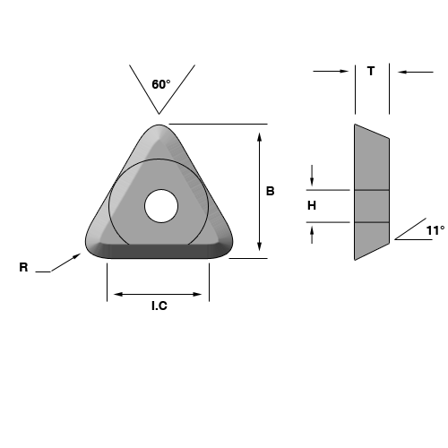

Insert Number | ISO Designation | Specifications |  |  |  |  |  | Grades
Insert Number | ISO Designation | E.P | I.C. | T | R | B | H | FM | FM | FMTCN | FM
TP-221  TP-222  TP-223 | TPGA 110304  TPGA 110308  TPGA 110312 | T-02  T-02  T-02 | 1/4  1/4  1/4 | 1/8  1/8  1/8 | 1/64  1/32  3/64 | .3675  .3438  .3281 | .150  .150  .150 |  |  | ♦  ♦  ♦
TP-321  TP-322  TP-323 | TPGA 160304  TPGA 160308  TPGA 160312 | T-01  T-01  T-01 | 3/8  3/8  3/8 | 1/8  1/8  1/8 | 1/64  1/32  3/64 | .5469  .5313  .5156 | .150  .150  .150 |  | ○  ○  ○ | ♦  ♦  ♦ | ♦  ♦

VNG 35° diamond negative rake Insert
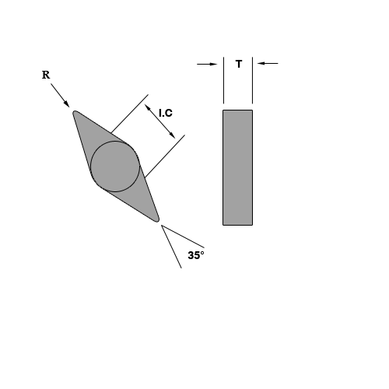

Insert Number | ISO Designation | Specifications |  |  |  | All Grades
Insert Number | ISO Designation | E.P | I.C. | T | R | FM1  02 | FM  64C | FM  73C | FM  Y515
VNG-331  VNG-332 | VNG 160404  VNG 160408 | T-02  T-02 | 3/8  3/8 | 3/16  3/16 | 1/64  1/32 | ♦  ♦ | ♦  ♦ | ♦  ♦ | ♦  ♦
VNG- 332 | VNG 190408 | T-02 | 1/8 | 3/16 | 1/32 | ♦ | ○ | ♦ | ○

VNGA 35° diamond negative rake Insert

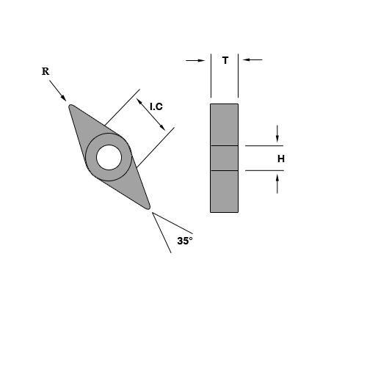

Insert Number | ISO Designation | Specifications |  |  |  |  | All Grades
Insert Number | ISO Designation | E.P | I.C. | T | R | H | FM  02 | FM  64C | FM  73C | FM  Y515
VNGA-331  VNGA-332 | VNGA 160404  VNGA 160408 | T-02  T-02 | 3/8  3/8 | 3/16  3/16 | 1/64  1/32 | .150  .150 | ♦  ♦ | ♦  ♦ | ♦  ♦ | ♦  ♦
VNGA- 432 | VNGA 190408 | T-02 | 1/8 | 3/16 | 1/32 | .203 | ♦ |  | ♦

LNM Rectangle negative rake inserts

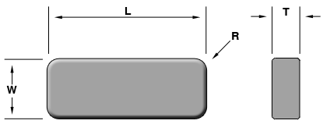

Insert Number | ISO Designation | Specifications |  |  |  |  | Grades
Insert Number | ISO Designation | E.P | L | T | R | W | FMAZ1 | FM  AZ2 | FM  AZ3 | FM
LNM-222 |  | T-02 | 1-1/2 | 1/5 | 1/32 | .750 |  |  | ♦
LNM-322 |  | T-02 | 3/8 | 1/8 | 1/32 | .5312 | ♦ |  | ♦
LNM-332  LNM-333  LNM-334 |  | T-02  T-02  T-02 | 3/8  3/8  3/8 | 3/16  3/16  3/16 | 1/32  3/64  1/16 | .5312  .5156  .5000 | ♦  ♦  ♦ | ♦  ♦  ♦ | ♦  ♦  ♦

ZT ^{Precision ground}

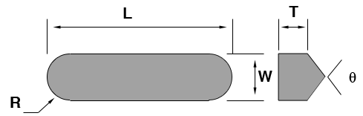

Insert Number | ISO Designation | Specifications |  |  |  |  | Grades
Insert Number | ISO Designation | θ | L | T | R | W | FMAZ1 | FM  AZ2 | FM  AZ3 | FM
ZT967  ZT969 |  | 90º | 0.500 | .250 | 1/8 | .1187 |  | ○ | ♦
ZT-322 |  |  | 3/8 | 1/8 | 1/32 | .5312 | ♦ |  | ♦ | ♦
ZT-332  ZT-333  ZT-334 |  |  | 3/8  3/8  3/8 | 3/16  3/16  3/16 | 1/32  3/64  1/16 | .5312  .5156  .5000 | ♦  ♦  ♦ | ♦  ♦  ♦ | ♦  ♦  ♦ | ♦  ♦  ♦

ZT ^{Precision ground}

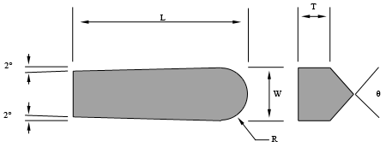

Insert Number | ISO Designation | Specifications |  |  |  |  | Grades
Insert Number | ISO Designation | θ | L | T | R | W | FMAZ1 | FM  AZ2 | FM  AZ3 | FM
ZT967 |  | 90º | 3/4 | 1/4 | 1/8 | 1/4 |  |  | ♦
ZT-322 |  |  | 3/8 | 1/8 | 1/32 | .5312 | ♦ |  | ♦
ZT-332  ZT-333  ZT-334 |  |  | 3/8  3/8  3/8 | 3/16  3/16  3/16 | 1/32  3/64  1/16 | .5312  .5156  .5000 | ♦  ♦  ♦ | ♦  ♦  ♦ | ♦  ♦  ♦

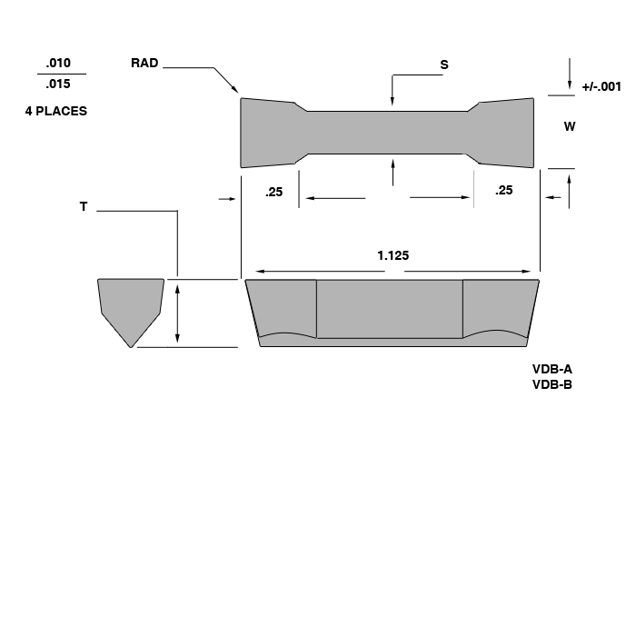
VDB

Insert Number | ISO Designation | Specifications |  |  |  | Grades
Insert Number | ISO Designation | E.P | W | S | T | FMAZ1 | FM  AZ2 | FM  AZ3 | FM
VDB-222 |  | T-02 | 1/4 | 1/8 | 1/32 |  |  | ♦
VDB-322 |  | T-02 | 3/8 | 1/8 | 1/32 | ♦ |  | ♦
VDB -332  VDB -333  VDB -334 |  | T-02  T-02  T-02 | 3/8  3/8  3/8 | 3/16  3/16  3/16 | 1/32  3/64  1/16 | ♦  ♦  ♦ | ♦  ♦  ♦ | ♦  ♦  ♦

VDB-R

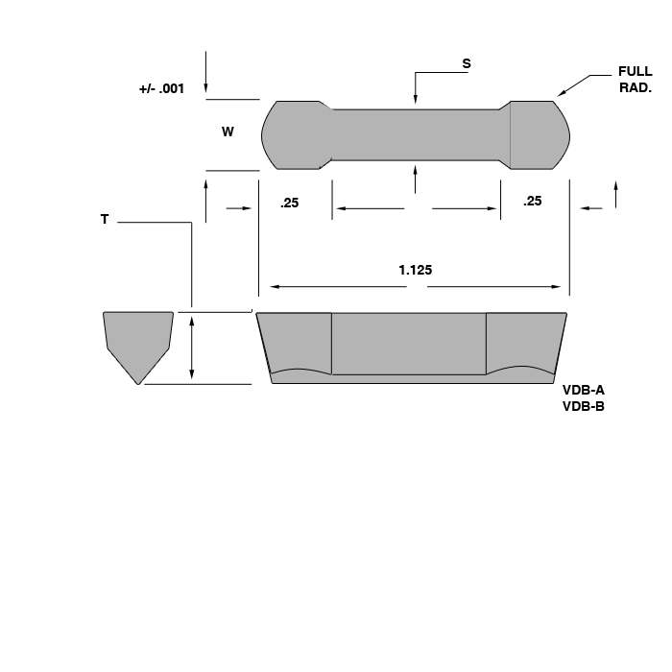

Insert Number | ISO Designation | Specifications |  |  |  | Grades
Insert Number | ISO Designation | E.P | W | S | T | FMAZ1 | FM  AZ2 | FM  AZ3 | FM
VDB-222 |  | T-02 | 1/4 | 1/8 | 1/32 |  |  | ♦
VDB-322 |  | T-02 | 3/8 | 1/8 | 1/32 | ♦ |  | ♦
VDB 332  VDB -333  VDB -334 |  | T-02  T-02  T-02 | 3/8  3/8  3/8 | 3/16  3/16  3/16 | 1/32  3/64  1/16 | ♦  ♦  ♦ | ♦  ♦  ♦ | ♦  ♦  ♦

Material | Hardness | Operation | Grade | Median Cutting Speed, sfm (m/min) | Median Feed Rate, ipr | Depth of Cut Inches
Carbon Steels | 100-250 BHN | Heavy Roughing | FMTCN | 1600 (480) | 0.014 | 0.120-0.500
Carbon Steels | 100-250 BHN | Roughing | FMAZ3 | 1600 (480) | 0.014 | 0.040-0.120
Carbon Steels | 100-250 BHN | Finishing | FMAZ1 | 2000 (600) | 0.008 | 0.012-0.040
Carbon Steels | 100-250 BHN | Fine Finishing | FMA | 2000 (600) | 0.004 | 0.004-0.020
Carbon, Alloy & Tool Steels | 250-400 BHN | Heavy Roughing | FMTCN | 800 (240) | 0.014 | 0.120-0.500
Carbon, Alloy & Tool Steels | 250-400 BHN | Roughing | FMAZ3 | 800 (240) | 0.014 | 0.040-0.120
Carbon, Alloy & Tool Steels | 250-400 BHN | Finishing | FMAZ2 | 1250 (375) | 0.008 | 0.012-0.040
Carbon, Alloy & Tool Steels | 250-400 BHN | Fine Finishing | FMAZ1 | 1250 (375) | 0.004 | 0.004-0.020
Hardened Steel | 36 - 48 HRC | Roughing | FMTCN | 900 (270) | 0.008 | 0.120-0.200
Hardened Steel | 36 - 48 HRC | Finishing | FMAZ3 | 900 (270) | 0.008 | 0.120-0.200
Hardened Steel | 50 - 56 HRC | Roughing | FMTCN | 600 (180) | 0.006 | 0.120
Hardened Steel | 50 - 56 HRC | Finishing | FMAZ3 | 600 (180) | 0.006 | 0.120
Hardened Steel | 58 – 64 HRC | Finishing | FMAZ3 | 420 (125) | 0.004 | 0.040
Chilled Cast Iron | 35 – 43 HRC | Roughing | FM02 | 450 (135) | 0.009 | 0.200
Chilled Cast Iron | 35 – 43 HRC | Finishing | FM73C | 450 (135) | 0.009 | 0.200
Chilled Cast Iron | 46 –53 HRC | Roughing | FM02 | 300 (90) | 0.006 | 0.200
Chilled Cast Iron | 46 –53 HRC | Finishing | FM73C | 300 (90) | 0.006 | 0.200
Chilled Cast Iron | 56 – 62 HRC | Roughing | FM02 | 200 (60) | 0.004 | 0.200
Chilled Cast Iron | 56 – 62 HRC | Finishing | FM64C | 200 (60) | 0.004 | 0.120 – 0.200
Gray Cast Iron | 140 – 280 BHN | Heavy Roughing | FM02 | 1600 (480) | 0.016 | 0.120 – 0.500
Gray Cast Iron | 140 – 280 BHN | Heavy Roughing | FM73C | 1600 (480) | 0.016 | 0.120 – 0.500
Gray Cast Iron | 140 – 280 BHN | Roughing | FM73C | 1600 (480) | 0.016 | 0.040 – 0.120
Gray Cast Iron | 140 – 280 BHN | Finishing | FM64C | 1800 (540) | 0.008 | 0.012 – 0.040
Gray Cast Iron | 140 – 280 BHN | Fine Finishing | FM55C | 1800 (540) | 0.004 | 0.004 – 0.020
Nodular Cast Iron | 140 – 240 BHN | Heavy Roughing | FM02 | 950 (285) | 0.016 | 0.120 – 0.500
Nodular Cast Iron | 140 – 240 BHN | Roughing | FM73C | 1050 (315) | 0.016 | 0.040 – 0.120
Nodular Cast Iron | 140 – 240 BHN | Finishing | FM64C | 1350 (405) | 0.008 | 0.012 – 0.040
Nodular Cast Iron | 140 – 240 BHN | Fine Finishing | FMYC | 1350 (405) | 0.004 | 0.004 – 0.020
Black & White Malleable Cast Iron | 120 – 280 BHN | Heavy Roughing | FM02 | 950 (285) | 0.016 | 0.120 – 0.500
Black & White Malleable Cast Iron | 120 – 280 BHN | Heavy Roughing | FM73C | 950 (285) | 0.016 | 0.120 – 0.500
Black & White Malleable Cast Iron | 120 – 280 BHN | Roughing | FM02 | 1050 (315) | 0.016 | 0.040 – 0.120
Black & White Malleable Cast Iron | 120 – 280 BHN | Finishing | FM55C | 1350 (405) | 0.008 | 0.012 – 0.040
Black & White Malleable Cast Iron | 120 – 280 BHN | Fine Finishing | FMYC | 1350 (405) | 0.004 | 0.004 – 0.012

Surface Speed  SFM = .262 x DIA x RPM  Revolutions Per Minutes  RPM = 3.82 x SFM /DIA  Feedrate (inches/minute)  IPM = IPR x RPM  Feed Rate (inches/revolution)  IPR = t _{chip} / cos α | Metal Removal Rate  Q = 12 x DOC x IPR x SFM (in³/ min)  Horsepower Required At The Spindle  HPS = Q x UHP  Horsepower Required At The Motor  HPM = HPS / EFF  Time In Cut (in seconds)  T = 15.7 x DIA x LOC / SFM x IPR (sec)  Or  T = 60 x LOC / IPM (sec)

Definition of Terms

DIA = Diameter of the Workpiece (inches)
DOC = Depth of Cut (inches)
EFF = Machine Efficiency
f = Feed rate (see IPM and IPR)
HPM = Horsepower Required at the Motor (HP)
HPS = Horsepower Required at the Spindle (HP)
IPM = Feed rate (inches per minute)
IPR = Feed rate (inches per revolution)
LOC = Length of Cut (inches)
Q = Metal Removal Rate (cubic inches per minute)
RPM = Revolutions per Minute
SFM = Surface Feet per Minute
T = Time (seconds)
t _{chip} = Chip Thickness (inches)
UHP = Unit Horsepower Factor
α = Lead Angle

Material | Hardness | Operation | Grade | Cutting Speed (SFM) |  |  | Feedrate (IPR) |  |  | Depth of Cut
 |  |  |  | From | Median | To | From | Median | To
Steels, Carbon Contents 0.3 % or Less | 110  BHN | Heavy Roughing |  | 600 | 1,600 | 2,300 | 0.012 | 0.014 | 0.024 | 0.120 to 0.500
Steels, Carbon Contents 0.3 % or Less | 110  BHN | Roughing |  | 600 | 2,000 | 3,000 | 0.012 | 0.014 | 0.024 | 0.040 to 0.120
Steels, Carbon Contents 0.3 % or Less | 110  BHN | Finishing |  | 1,000 | 2,300 | 4,000 | 0.008 | - | 0.060* | 0.012 to 0.040
Steels, Carbon Contents 0.3 % or Less | 110  BHN | Fine Finishing |  | 1,000 | 2,300 | 4,000 | 0.003 | - | 0.014* | 0.004 to 0.020
Steels, Carbon Contents 0.3 % or Less | 170  BHN | Heavy Roughing |  | 500 | 1,300 | 2,000 | 0.012 | 0.014 | 0.024 | 0.120 to 0.500
Steels, Carbon Contents 0.3 % or Less | 170  BHN | Roughing |  | 500 | 1,600 | 2,600 | 0.012 | 0.014 | 0.024 | 0.040 to 0.120
Steels, Carbon Contents 0.3 % or Less | 170  BHN | Finishing |  | 650 | 2,100 | 3,300 | 0.008 | - | 0.060* | 0.012 to 0.040
Steels, Carbon Contents 0.3 % or Less | 170  BHN | Fine Finishing |  | 650 | 2,100 | 3,500 | 0.003 | - | 0.014* | 0.004 to 0.020
Steels, Carbon Contents 0.3 % or Less | 230 BHN | Heavy Roughing |  | 400 | 1,300 | 1,600 | 0.012 | 0.014 | 0.024 | 0.120 to 0.500
Steels, Carbon Contents 0.3 % or Less | 230 BHN | Roughing |  | 400 | 1,300 | 2,300 | 0.012 | 0.014 | 0.024 | 0.040 to 0.120
Steels, Carbon Contents 0.3 % or Less | 230 BHN | Finishing |  | 500 | 1,800 | 2,600 | 0.008 | - | 0.060* | 0.012 to 0.040
Steels, Carbon Contents 0.3 % or Less | 230 BHN | Fine Finishing |  | 500 | 1,800 | 2,600 | 0.003 | - | 0.014* | 0.004 to 0.020
Steels, Carbon Contents 0.3 % or Less | 290 BHN | Heavy Roughing |  | 350 | 1,000 | 1,300 | 0.012 | 0.014 | 0.024 | 0.120 to 0.500
Steels, Carbon Contents 0.3 % or Less | 290 BHN | Roughing |  | 350 | 1,000 | 1,600 | 0.012 | 0.014 | 0.024 | 0.040 to 0.120
Steels, Carbon Contents 0.3 % or Less | 290 BHN | Finishing |  | 350 | 1,500 | 1,600 | 0.008 | - | 0.060* | 0.012 to 0.040
Steels, Carbon Contents 0.3 % or Less | 290 BHN | Fine Finishing |  | 350 | 1,500 | 2,000 | 0.003 | - | 0.014* | 0.004 to 0.020
Steels, Carbon Contents 0.3 % or Less | 350 BHN | Heavy Roughing |  | 250 | 800 | 1,100 | 0.012 | 0.014 | 0.024 | 0.120 to 0.500
Steels, Carbon Contents 0.3 % or Less | 350 BHN | Roughing |  | 250 | 800 | 1,100 | 0.012 | 0.014 | 0.024 | 0.040 to 0.120
Steels, Carbon Contents 0.3 % or Less | 350 BHN | Finishing |  | 250 | 1,300 | 1,500 | 0.008 | - | 0.060* | 0.012 to 0.040
Steels, Carbon Contents 0.3 % or Less | 350 BHN | Fine Finishing |  | 250 | 1,300 | 1,500 | 0.003 | - | 0.014* | 0.004 to 0.020
Steels, Carbon Contents 0.3 % or Less | 400 BHN | Heavy Roughing |  | 230 | 650 | 1,000 | 0.012 | 0.014 | 0.024 | 0.120 to 0.500
Steels, Carbon Contents 0.3 % or Less | 400 BHN | Roughing |  | 230 | 650 | 1,000 | 0.012 | 0.014 | 0.024 | 0.040 to 0.120
Steels, Carbon Contents 0.3 % or Less | 400 BHN | Finishing |  | 230 | 1,000 | 1,100 | 0.008 | - | 0.060* | 0.012 to 0.040
Steels, Carbon Contents 0.3 % or Less | 400 BHN | Fine Finishing |  | 230 | 1,000 | 1,100 | 0.003 | - | 0.014* | 0.004 to 0.020

Material | Hardness | Operation | Grade | Cutting Speed (SFM) |  |  | Feedrate (IPR) |  |  | Depth of Cut
 |  |  |  | From | Median | To | From | Median | To
Steels, Carbon Content 0.35%  or More | 110 BHN | Heavy Roughing |  | 600 | 2,000 | 2,300 | 0.012 | 0.014 | 0.024 | 0.120 to 0.500
Steels, Carbon Content 0.35%  or More | 110 BHN | Roughing |  | 650 | 2,000 | 2,600 | 0.012 | 0.014 | 0.024 | 0.040 to 0.120
Steels, Carbon Content 0.35%  or More | 110 BHN | Finishing |  | 650 | 2,300 | 3,300 | 0.008 | - | 0.060* | 0.012 to 0.040
Steels, Carbon Content 0.35%  or More | 110 BHN | Fine Finishing |  | 650 | 2,300 | 3,300 | 0.003 | - | 0.014* | 0.004 to 0.020
Steels, Carbon Content 0.35%  or More | 170 BHN | Heavy Roughing |  | 500 | 1,600 | 2,000 | 0.012 | 0.014 | 0.024 | 0.120 to 0.500
Steels, Carbon Content 0.35%  or More | 170 BHN | Roughing |  | 500 | 1,600 | 2,300 | 0.012 | 0.014 | 0.024 | 0.040 to 0.120
Steels, Carbon Content 0.35%  or More | 170 BHN | Finishing |  | 500 | 2,100 | 2,600 | 0.008 | - | 0.060* | 0.012 to 0.040
Steels, Carbon Content 0.35%  or More | 170 BHN | Fine Finishing |  | 500 | 2,100 | 2,600 | 0.003 | - | 0.014* | 0.004 to 0.020
Steels, Carbon Content 0.35%  or More | 230 BHN | Heavy Roughing |  | 400 | 1,300 | 1,600 | 0.012 | 0.014 | 0.024 | 0.120 to 0.500
Steels, Carbon Content 0.35%  or More | 230 BHN | Roughing |  | 400 | 1,300 | 2,000 | 0.012 | 0.014 | 0.024 | 0.040 to 0.120
Steels, Carbon Content 0.35%  or More | 230 BHN | Finishing |  | 400 | 1,800 | 2,000 | 0.008 | - | 0.060* | 0.012 to 0.040
Steels, Carbon Content 0.35%  or More | 230 BHN | Fine Finishing |  | 400 | 1,800 | 2,000 | 0.003 | - | 0.014* | 0.004 to 0.020
Steels, Carbon Content 0.35%  or More | 290 BHN | Heavy Roughing |  | 350 | 1,000 | 1,300 | 0.012 | 0.014 | 0.024 | 0.120 to 0.500
Steels, Carbon Content 0.35%  or More | 290 BHN | Roughing |  | 350 | 1000 | 1,600 | 0.012 | 0.014 | 0.024 | 0.040 to 0.120
Steels, Carbon Content 0.35%  or More | 290 BHN | Finishing |  | 350 | 1,500 | 1,600 | 0.008 | - | 0.060* | 0.012 to 0.040
Steels, Carbon Content 0.35%  or More | 290 BHN | Fine Finishing |  | 350 | 1,500 | 1,600 | 0.003 | - | 0.014* | 0.004 to 0.020

Material | Hardness | Operation | Grade | Cutting Speed (SFM) |  |  | Feedrate (IPR) |  |  | Depth of Cut
 |  |  |  | From | Median | To | From | Median | To
Steels, Carbon Content 0.35%  or More | 350 BHN | Heavy Roughing | FMAZ3 | 250 | 800 | 2,300 | 0.012 | 0.014 | 0.024 | 0.120 to 0.500
Steels, Carbon Content 0.35%  or More | 350 BHN | Roughing | FMAZ3 | 250 | 800 | 2,600 | 0.012 | 0.014 | 0.024 | 0.040 to 0.120
Steels, Carbon Content 0.35%  or More | 350 BHN | Finishing | FMAZ2 | 250 | 1,300 | 3,300 | 0.008 | - | 0.060* | 0.012 to 0.040
Steels, Carbon Content 0.35%  or More | 350 BHN | Fine Finishing | FMA | 250 | 1,300 | 3,300 | 0.003 | - | 0.014* | 0.004 to 0.020
Steels, Carbon Content 0.35%  or More | 400 BHN | Heavy Roughing | FMAZ3 | 230 | 650 | 1,000 | 0.012 | 0.014 | 0.024 | 0.120 to 0.500
Steels, Carbon Content 0.35%  or More | 400 BHN | Roughing | FMAZ3 | 230 | 650 | 1,000 | 0.012 | 0.014 | 0.024 | 0.040 to 0.120
Steels, Carbon Content 0.35%  or More | 400 BHN | Finishing | FMAZ2 | 230 | 1,000 | 1,100 | 0.008 | - | 0.060* | 0.012 to 0.040
Steels, Carbon Content 0.35%  or More | 400 BHN | Fine Finishing | FMAZ! | 230 | 1,000 | 1,100 | 0.003 | - | 0.014* | 0.004 to 0.020
Hardened Steels (36 to 64 HRC) | 36 HRC | Roughing Finishing | FMAZ3  FMAZ1 | 300 | 1,050 | 1,300 |  | 0.014 max** |  | 0.200
Hardened Steels (36 to 64 HRC) | 42 HRC | Roughing Finishing | FMAZ3  FMAZ2 | 260 | 900 | 1,150 |  | 0.011 max** |  | 0.200
Hardened Steels (36 to 64 HRC) | 48 HRC | Roughing Finishing | FMAZ3  FMAZ2 | 230 | 750 | 980 |  | 0.008 max** |  | 0.120
Hardened Steels (36 to 64 HRC) | 52 HRC | Roughing Finishing | FMAZ3  FMAZ2 | 200 | 660 | 800 |  | 0.007 max** |  | 0.12
Hardened Steels (36 to 64 HRC) | 56 HRC | Roughing Finishing | FMAZ3  FMAZ2 | 170 | 550 | 650 |  | 0.006 max** |  | 0.120
Hardened Steels (36 to 64 HRC) | 60 HRC | Finishing | FMAZ3  FMAZ3 | 140 | 450 | 550 |  | 0.005 max** |  | 0.040
Hardened Steels (36 to 64 HRC) | 64 HRC | Finishing | FMAZ3  FMAZ3 | 100 | 380 | 450 |  | 0.004 max** |  | 0.040
Chilled Cast  Irons | 35 HRC | Roughing Finishing | FMAZ3  FMAZ1 | 390 | 520 | 790 |  | 0.011 max** |  | 0.200
Chilled Cast  Irons | 40 HRC | Roughing Finishing | FMAZ3  FMAZ2 | 330 | 460 | 720 |  | 0.010 max** |  | 0.200
Chilled Cast  Irons | 43 HRC | Roughing Finishing | FMAZ3  FMAZ2 | 300 | 390 | 660 |  | 0.009 max** |  | 0.200
Chilled Cast  Irons | 46 HRC | Roughing Finishing | FMAZ3  FMAZ2 | 250 | 330 | 590 |  | 0.008 max** |  | 0.200
Chilled Cast  Irons | 50 HRC | Roughing Finishing | FMAZ3  FMAZ2 | 200 | 290 | 520 |  | 0.007 max** |  | 0.200
Chilled Cast  Irons | 53 HRC | Roughing Finishing | FMAZ3  FMAZ3 | 170 | 260 | 460 |  | 0.006 max** |  | 0.200
Chilled Cast  Irons | 56 HRC | Roughing Finishing | FMAZ3  FMAZ3 | 150 | 230 | 390 |  | 0.006 max** |  | 0.200
Chilled Cast  Irons | 59 HRC | Roughing Finishing | FMAZ3  FMAZ1 | 130 | 200 | 330 |  | 0.005 max** |  | 0.200
Chilled Cast  Irons | 62 HRC | Roughing Finishing | FMAZ3  FMAZ2 | 100 | 160 | 260 |  | 0.004 max** |  | 0.200

Material | Hardness | Operation | Grade | Cutting Speed (SFM) |  |  | Feedrate (IPR) |  |  | Depth of Cut
 |  |  |  | From | Median | To | From | Median | To
Gray Cast Irons | 140 to 210 BHN | Heavy Roughing** | FM02 | 650 | 1,600 | 2,600 | 0.010 | 0.016 | 0.028 | 0.120 to 0.625
Gray Cast Irons | 140 to 210 BHN | Roughing** | FM73C | 650 | 2,000 | 3,300 | 0.010 | 0.016 | 0.028 | 0.040 to 0.120
Gray Cast Irons | 140 to 210 BHN | Finishing | FMYC | 650 | 2,300 | 3,900 | 0.008 | - | 0.060* | 0.012 to 0.040
Gray Cast Irons | 140 to 210 BHN | Fine Finishing | FMYC | 650 | 2,300 | 3,900 | 0.003 | - | 0.014* | 0.004 to 0.020
Gray Cast Irons | 220 to 240 BHN | Heavy Roughing** | FM02 | 650 | 1,300 | 2,000 | 0.010 | 0.016 | 0.028 | 0.120 to 0.625
Gray Cast Irons | 220 to 240 BHN | Roughing** | FM73C | 650 | 1,600 | 2,000 | 0.010 | 0.016 | 0.028 | 0.040 to 0.120
Gray Cast Irons | 220 to 240 BHN | Finishing | FMYC | 650 | 1,700 | 2,300 | 0.008 | - | 0.060* | 0.012 to 0.040
Gray Cast Irons | 220 to 240 BHN | Fine Finishing | FMYC | 650 | 1,700 | 2,300 | 0.003 | - | 0.014* | 0.004 to 0.020
Gray Cast Irons | 250 to 280 BHN | Heavy Roughing** | FM02 | 350 | 1,000 | 1,300 | 0.010 | 0.016 | 0.028 | 0.120 to 0.625
Gray Cast Irons | 250 to 280 BHN | Roughing** | FM73C | 350 | 1,100 | 1,300 | 0.010 | 0.016 | 0.028 | 0.040 to 0.120
Gray Cast Irons | 250 to 280 BHN | Finishing | FM64C | 500 | 1,200 | 1,500 | 0.008 | - | 0.060* | 0.012 to 0.040
Gray Cast Irons | 250 to 280 BHN | Fine Finishing | FMYC | 500 | 1,200 | 1,500 | 0.003 | - | 0.014* | 0.004 to 0.020
Nodular Cast Irons | 140 BHN | Heavy Roughing | FM02 | 650 | 1,100 | 1,300 | 0.010 | 0.016 | 0.028 | 0.120 to 0.625
Nodular Cast Irons | 140 BHN | Roughing | FM73C | 650 | 1,300 | 1,800 | 0.010 | 0.016 | 0.028 | 0.040 to 0.120
Nodular Cast Irons | 140 BHN | Finishing | FM64C | 800 | 1,600 | 2,000 | 0.008 | - | 0.060* | 0.012 to 0.040
Nodular Cast Irons | 140 BHN | Fine Finishing | FMYC | 800 | 1,600 | 2,000 | 0.003 | - | 0.014* | 0.004 to 0.020
Nodular Cast Irons | 190 BHN | Heavy Roughing | FM02 | 650 | 1,100 | 1,300 | 0.010 | 0.016 | 0.028 | 0.120 to 0.625
Nodular Cast Irons | 190 BHN | Roughing | FM64C | 650 | 1,300 | 1,800 | 0.010 | 0.016 | 0.028 | 0.040 to 0.120
Nodular Cast Irons | 190 BHN | Finishing | FMYC | 1,000 | 1,600 | 1,800 | 0.008 | - | 0.060* | 0.012 to 0.040
Nodular Cast Irons | 190 BHN | Fine Finishing | FMYC | 1,000 | 1,600 | 1,800 | 0.003 | - | 0.014* | 0.004 to 0.020
Nodular Cast Irons | 240 BHN | Heavy Roughing | FM02 | 350 | 800 | 1,150 | 0.010 | 0.016 | 0.028 | 0.120 to 0.625
Nodular Cast Irons | 240 BHN | Roughing | FM64C | 350 | 800 | 1,150 | 0.010 | 0.016 | 0.028 | 0.040 to 0.120
Nodular Cast Irons | 240 BHN | Finishing | FMYC | 500 | 1,150 | 1,300 | 0.008 | - | 0.060* | 0.012 to 0.040
Nodular Cast Irons | 240 BHN | Fine Finishing | FMYC | 500 | 1,150 | 1,300 | 0.003 | - | 0.014* | 0.004 to 0.020

Material | Hardness | Operation | Grade | Cutting Speed (SFM) |  |  | Feedrate (IPR) |  |  | Depth of Cut
 |  |  |  | From | Median | To | From | Median | To
Black Malleable Cast Irons | 140 to 190 BHN | Heavy Roughing** | FM02 | 650 | 1,600 | 2,600 | 0.010 | 0.016 | 0.028 | 0.120 to 0.625
Black Malleable Cast Irons | 140 to 190 BHN | Roughing** | FM73C | 650 | 2,300 | 3,300 | 0.010 | 0.016 | 0.028 | 0.040 to 0.120
Black Malleable Cast Irons | 140 to 190 BHN | Finishing | FM64C | 650 | 2,300 | 3,300 | 0.008 | - | 0.060* | 0.012 to 0.040
Black Malleable Cast Irons | 140 to 190 BHN | Fine Finishing | FM55C | 650 | 2,300 | 3,300 | 0.003 | - | 0.014* | 0.004 to 0.020
Black Malleable Cast Irons | 200 to 250 BHN | Heavy Roughing** | FM02 | 650 | 1,300 | 2,000 | 0.010 | 0.016 | 0.028 | 0.120 to 0.625
Black Malleable Cast Irons | 200 to 250 BHN | Roughing** | FM73C | 650 | 1,600 | 2,000 | 0.010 | 0.016 | 0.028 | 0.040 to 0.120
Black Malleable Cast Irons | 200 to 250 BHN | Finishing | FM64C | 650 | 1,600 | 2,300 | 0.008 | - | 0.060* | 0.012 to 0.040
Black Malleable Cast Irons | 200 to 250 BHN | Fine Finishing | FMYC | 650 | 1,600 | 2,300 | 0.003 | - | 0.014* | 0.004 to 0.020
Black Malleable Cast Irons | 260 to 290 BHN | Heavy Roughing** | FM02 | 350 | 1,000 | 1,300 | 0.010 | 0.016 | 0.028 | 0.120 to 0.625
Black Malleable Cast Irons | 260 to 290 BHN | Roughing** | FM02 | 350 | 1,000 | 1,300 | 0.010 | 0.016 | 0.028 | 0.040 to 0.120
Black Malleable Cast Irons | 260 to 290 BHN | Finishing | FMYC | 350 | 1,100 | 1,500 | 0.008 | - | 0.060* | 0.012 to 0.040
Black Malleable Cast Irons | 260 to 290 BHN | Fine Finishing | FMYC | 350 | 1,100 | 1,500 | 0.003 | - | 0.014* | 0.004 to 0.020
White Malleable Cast Irons | 120 to 190 BHN | Heavy Roughing** | FM02 | 650 | 1,600 | 2,600 | 0.010 | 0.016 | 0.028 | 0.120 to 0.625
White Malleable Cast Irons | 120 to 190 BHN | Roughing** | FM73C | 650 | 2,000 | 3,300 | 0.010 | 0.016 | 0.028 | 0.040 to 0.120
White Malleable Cast Irons | 120 to 190 BHN | Finishing | FM64C | 650 | 2,300 | 3,300 | 0.008 | - | 0.060* | 0.012 to 0.040
White Malleable Cast Irons | 120 to 190 BHN | Fine Finishing | FM55C | 650 | 2,300 | 3,300 | 0.003 | - | 0.014* | 0.004 to 0.020
White Malleable Cast Irons | 200 to 250 BHN | Heavy Roughing** | FM02 | 650 | 1,300 | 2,000 | 0.010 | 0.016 | 0.028 | 0.120 to 0.625
White Malleable Cast Irons | 200 to 250 BHN | Roughing** | FM73C | 650 | 1,600 | 2,000 | 0.010 | 0.016 | 0.028 | 0.040 to 0.120
White Malleable Cast Irons | 200 to 250 BHN | Finishing | FM64C | 650 | 1,600 | 2,300 | 0.008 | - | 0.060* | 0.012 to 0.040
White Malleable Cast Irons | 200 to 250 BHN | Fine Finishing | FMYC | 650 | 1,600 | 2,300 | 0.003 | - | 0.014* | 0.004 to 0.020
White Malleable Cast Irons | 260 to 290 BHN | Heavy Roughing** | FM02 | 350 | 1,000 | 1,300 | 0.010 | 0.016 | 0.028 | 0.120 to 0.625
White Malleable Cast Irons | 260 to 290 BHN | Roughing** | FM02 | 350 | 1,00 | 1,800 | 0.010 | 0.016 | 0.028 | 0.040 to 0.120
White Malleable Cast Irons | 260 to 290 BHN | Finishing | FMYC | 350 | 1,100 | 1,500 | 0.008 | - | 0.060* | 0.012 to 0.040
White Malleable Cast Irons | 260 to 290 BHN | Fine Finishing | FMYC | 350 | 1,100 | 1,500 | 0.003 | - | 0.014* | 0.004 to 0.020

Material | Hardness | Operation | Grade | Cutting Speed (SFM) |  |  | Feedrate (IPR) |  |  | Depth of Cut
 |  |  |  | From | Median | To | From | Median | To
High Temperature Nickel Base Alloys**  Inconel 600 Series, Monel | 115 BHN | Roughing | FMYC | 500 | 800 | 1,000 | 0.005 | 0.006 | 0.010 | 0.150
 | 115 BHN | Semifinishing | FMYC | 600 | 900 | 1,200 | 0.005 | 0.006 | 0.010 | 0.060
 | 200 BHN | Roughing | FMYC | 500 | 700 | 900 | 0.004 | 0.006 | 0.008 | 0.150
 | 200 BHN | Semifinishing | FMYC | 600 | 800 | 1,000 | 0.004 | 0.006 | 0.008 | 0.060
 | 360 BHN | Roughing | FMYC | 300 | 500 | 700 | 0.004 | 0.006 | 0.008 | 0.150
 | 360 BHN | Semifinishing | FMYC | 400 | 600 | 800 | 0.004 | 0.006 | 0.008 | 0.060
Inconel 700 Series Waspalloy | 360 BHN | Roughing | FMYC | 500 | 800 | 1,100 | 0.005 | 0.006 | 0.010 | 0.100
Inconel 700 Series Waspalloy | 360 BHN | Semifinishing | FMYC | 600 | 900 | 1,200 | 0.005 | 0.006 | 0.010 | 0.060
Inconel 700 Series Waspalloy | 450 BHN | Roughing | FMYC | 300 | 700 | 900 | 0.004 | 0.006 | 0.008 | 0.100
Inconel 700 Series Waspalloy | 450 BHN | Semifinishing | FMYC | 400 | 800 | 1,000 | 0.004 | 0.006 | 0.008 | 0.060
Hastelloy, Rene | 300 BHN | Roughing | FMYC | 300 | 500 | 700 | 0.003 | 0.005 | 0.008 | 0.100
Hastelloy, Rene | 300 BHN | Semifinishing | FMYC | 400 | 600 | 800 | 0.003 | 0.005 | 0.008 | 0.060
Hastelloy, Rene | 375 BHN | Roughing | FMYC | 250 | 400 | 500 | 0.002 | 0.004 | 0.006 | 0.075
Hastelloy, Rene | 375 BHN | Semifinishing | FMYC | 300 | 500 | 600 | 0.002 | 0.004 | 0.006 | 0.060

Ten Suggestions for the Ceramic User

The properties of ceramic-based cutting materials are completely different from conventional materials, such as cemented carbides and high-speed steel. These are ten basic recommendations for the application of ceramic cutting tools:
- Best efficiency with ceramic cutting tools is achieved in large quantity metal removal operations, in the machining of hard materials and in the machining of large work pieces.

- Best efficiency with ceramic cutting tools is achieved with the highest cutting speeds possible and with square or round indexable inserts.

- Rigid machine tools, safe clamping devices and rigid workpieces are recommended for machining with ceramic cutting tools.

- Clutches and brakes of the machine tool should be designed for “higher operating frequency” or shorter machining cycles.

- Chip conveyors, capable of handling large amounts of chips (20 lbs per minute, minimum), should be attached to the machine tool.

- Gain experience with ceramic cutting tools by machining materials with good machinability, such as grey cast iron or carbon steel. Do not expect immediate solutions for exotic materials or complex workpieces.

- The conversion to ceramic cutting tools requires a review of the machining sequence. At the entry point of the cutting edge, a precut chamfer or a reduced feedrate is recommended.

- Machine operators need adequate training to accept the highly productive ceramic cutting tools.

- Machining parameter should be precisely specified to prevent misapplications.

- Coolants are NOT required, except when machining high temperature alloys.

Maximum Feedrate for Turning 1045 (200 BHN) With Ceramic Inserts
Toolholder | Side Cutting Edge Angle | Cutting Edge Angle | Nose Radius |  |  |  |  | Protective Chamfer
Toolholder | Side Cutting Edge Angle | Cutting Edge Angle | 5 | 4 | 3 | 2 | 1
CSSN | 45º | 90º | 0.022 | 0.020 | 0.014 | 0.010 | 0.006 | T00820
CSRN | 15º | 90º | 0.015 | 0.014 | 0.011 | 0.007 | 0.007 | T00820
CCLN | -5º | 80º | 0.014 | 0.013 | 0.010 | 0.006 | 0.006 | T00820
CDJN | -3º | 55º | 0.010 | 0.009 | 0.007 | 0.005 | 0.005 | T00820

Maximum Feedrate for Turning 1045 (180 BHN) With Ceramic Inserts
Toolholder | Side Cutting Edge Angle | Cutting Edge Angle | Nose Radius |  |  |  |  | Protective Chamfer
Toolholder | Side Cutting Edge Angle | Cutting Edge Angle | 5 | 4 | 3 | 2 | 1
CSSN | 45º | 90º | 0.025 | 0.022 | 0.016 | 0.011 | 0.007 | T00820
CSRN | 15º | 90º | 0.018 | 0.016 | 0.012 | 0.008 | 0.006 | T00820
CCLN | -5º | 80º | 0.016 | 0.014 | 0.011 | 0.007 | 0.005 | T00820
CDJN | -3º | 55º | 0.011 | 0.010 | 0.008 | 0.006 | 0.003 | T00820

For the machining of chilled cast iron and hardened ferrous metals, the selection of the correct chip thickness relative to the hardness is extremely important. The application of round inserts requires close control of the feedrate. When turning with round inserts, the undeformed chip will have a shape as shown in the picture below:
Table 1
Hardness |  |  |  | Recommended Maximum Chip Thickness ( t_{chip})
Brinell | Shore C | Vickers | Rockwell
225 | 34 | 237 | 20 | 0.014
255 | 38 | 266 | 25 | 0.013
285 | 42 | 302 | 30 | 0.012
325 | 48 | 345 | 35 | 0.011
370 | 54 | 390 | 40 | 0.010
400 | 57 | 425 | 43 | 0.009
480 | 67 | 513 | 50 | 0.008
525 | 71 | 560 | 53 | 0.007
580 | 73 | 613 | 56 | 0.006
635 | 80 | 674 | 59 | 0.005
690 | 85 | 746 | 62 | 0.004
Table 2
Depth of Cut | Factor M for Round Inserts With Various I.C.
Depth of Cut | 1/4 | 3/8 | 1/2 | 5/8 | 3/4 | 1 | 1 1/4
0.012 | 2.3 | 2.8 | 3.3 | 3.6 | 4.0 | 4.6 | 5.1
0.020 | 1.8 | 2.2 | 2.6 | 2.8 | 3.1 | 3.6 | 4.0
0.040 | 1.4 | 1.6 | 1.8 | 2.0 | 2.2 | 2.6 | 2.8
0.060 | ___ | 1.4 | 1.5 | 1.7 | 1.8 | 2.1 | 2.3
0.080 | ___ | ___ | 1.4 | 1.5 | 1.6 | 1.8 | 2.0
0.120 | ___ | ___ | ___ | 1.3 | 1.4 | 1.5 | 1.7
0.160 | ___ | ___ | ___ | ___ | ___ | 1.4 | 1.5

Surface Speed  SFM = .262 x DIA x RPM  Revolutions Per Minute  RPM = 3.82 x SFM / DIA  Feedrate (inches/minute)  IPM = IPR x RPM  Chip Thickness  IPR = t_{chip} | Metal Removal Rate  Q = 12 x WOC x IPR x SFM (in³/min)  Horsepower Required At The Spindle  HPS = Q x UHP  Horsepower Required At The Motor  HPM = HPS/EFF  Time In Cut (in seconds)  T= 7.85 x DOC x (DIA + DIAG)/ SFM x IPR (sec)  Or  T = 60 x DOC / IPM (sec)

Definition of Terms

DIA = Diameter of the Workpiece (inches)
DIAG = Diameter of Groove (inches)
(see figures above for details)
DOC = Depth of Cut (inches)
EFF = Machine Efficiency
f = Feedrate (see IPM and IPR)
HPM = Horsepower Required at the Motor (HP)
HPS = Horsepower Required at the Spindle
IPM = Feedrate (inches per minute)

IPR = Feedrate (inches per revolution)
Q = Metal Removal rate (cubic inches per minute)
RPM = Revolutions per Minute
SFM = Surface Feet per Minute
T = Time (seconds)
t_{chip} = Chip Thickness (inches)
UHP = Unit Horsepower Factor
WOC = Width of Cut or Groove Width (inches)

For optimal application of the ceramic cutting tools, the edge preparation should be adjusted to the cutting tool material, the work-piece material and the machining operation being applied. The edge preparation of ceramic cutting tools consists of designing a chamfer or a hone. The chamfer is defined by the width (W) and the angle (α), while the hone is defined only by the radius (r).

Chamfer Hone

Width (W)
R
Angle (α)

Three standard chamfer sizes are designed:

Designation | Width (W) | Angle (α)
T-01  T-02  T-03 | 0.003”  0.008”  0.012” | 20°  25°  30°

